April 3, 2014

Dr. Jennifer H. Herman
Director, Center for Excellence in Teaching
Simmons College, P113A
(617) 521-2025
Jennifer.herman@simmons.edu

Dr. Laura Saunders
Assistant Professor
Graduate School of Library and Information Science

Dear Dr. Saunders,

Thank you for your participation in the Center for Excellence in Teaching’s Classroom Observation and Small Group Individual Diagnosis (SGID) program. You welcomed CET staff to chat with students in your Reference/Information Services online class using GoToMeeting on April 1, 2014 and April 3, 2014. Later, CET staff met with you for a follow-up consultation to discuss the results.

CET’s classroom observation is a confidential and voluntary service that allows faculty members to receive detailed feedback and insights on their teaching. The observation is followed by the SGID, a professional development tool that elicits detailed discussion-based student feedback. After the CET facilitator observes part of the class, the faculty member leaves and the facilitator asks small groups of students to discuss the three best aspects of the course and the three areas that are the greatest impediments to their learning. The facilitator later discusses the compiled, anonymous student feedback with the faculty member. The student feedback gathered through this process tends to be much more accurate, detailed, and useful than data from end-of-semester written student evaluations.

Faculty members who participate in this program benefit in a number of ways. From the data gathered, they are able to improve a course while it is still in progress or make improvements to the course for future semesters. They are able to demonstrate to students that they are invested in their learning, which contributes to a more positive classroom culture. Participants are also able to address hidden problems in a course that may have been impeding student learning.

Your participation in the Classroom Observation and SGID program demonstrates a dedication, openness, and willingness to improve the quality of your teaching. We hope that the observation, student feedback, and follow-up consultation continue to support your efforts to improve the quality of your teaching.

Thank you again for your participation,
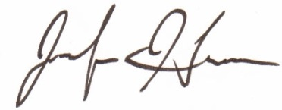
Jennifer H. Herman

